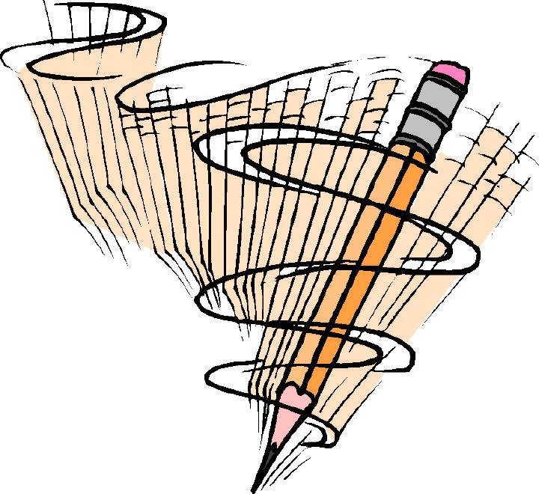 | GT Humanities Enrichment Seminar  Mr. Jones  2013-2014

Questions to be investigated. (These may change if students’ interests take class in a different direction.)

- Is beauty a matter of fact or a matter of taste?
- Is lying always wrong?
- Why is English spelling and grammar so confusing?
- Do animals have rights?
- Who am I and how do I know?

Course Description
The term “humanities” is used to describe a wide range of academic disciplines, including classical studies, linguistics, literature, philosophy, visual arts, music, and many more. This course aims to introduce students to these disciplines by investigating a few “big questions” that are often sidestepped due to limited class time in other classes. Attempting to answer questions like “What is a number?” or “What makes something beautiful?” or “Why is English spelling and grammar so confusing?” can lead to a deeper understanding of the essential skills and knowledge taught in the core classes.
Students will learn how to think creatively and critically, to reason, and to ask questions through studying the humanities. These skills are taught in the other “core” subjects, but the connections between the diverse knowledge that students are expected to learn are often lost. The goal of this course is to reconnect those ideas.
Although this course is titled “G/T Humanities Enrichment Seminar,” it has been developed to be appropriate and enriching for students of all levels. (The confusing course title is a byproduct of the scheduling program.) In the development of the course’s curriculum, I focused on the “enrichment” aspect and I will continue to refine the curriculum to make the course enriching for every student.

Absences & Missed Work
- If you are absent when an assignment is due, it is your responsibility to hand in the assignment when you return.
- If you are absent when an assignment is given, see me when you return to find out what you have missed. You will have the number of days you were absent to make up your work.
- If you are absent for an extended period, reasonable due dates will be determined.

BMMS Code of Conduct
Bobcats RoaRRR!
We will be READY for our classes.
We will be RESPONSIBLE in order to achieve our best.
We will be RESPECTFUL so our school is safe and orderly.

Required Materials
Come to class each day with the following items:
- Single subject notebook
- Writing Utensil
- Assignment Book
- An curious spirit and open mind

Keep in Touch
E-mail

Justin_jones@hcpss.org

Class Website
http://jonesbmms.weebly.com/index.html

Students will earn points for each assignment as listed below. |  | Interim and Semester grades will be calculated with this weighting formula:
Classwork and participation: | 10-20 points
Homework: | 10-20 points
Projects: | 25-75 points
Prepared for class:  (writing utensil, notebook) | 2 points/day

Please sign to indicate that you have read and understand the expectations for the class this year and return to Mr. Jones for a homework grade.

Students name (printed): ______________________________________________
Student’s signature: ______________________________________________
Parent/Guardian signature: ______________________________________________

Please complete this short survey to help me plan for using technology and online resources this year.

Does your child have the use of a computer with Internet access?
Yes No

If yes, then would your child be able to complete homework assignments using the Internet on a regular basis?
Yes No
If no, then would your child be able to stay after school to complete assignments that require Internet access?
Yes No

